# Browser Login

You can use the Web browser on a supported device to connect to iPass Inflight Wi-Fi, without launching the iPass application. For assistance in connecting, or to obtain your iPass credentials, contact your IT administrator.

1. At **10,000 feet altitude or greater**, on your device, launch your Web browser. The Gogo landing page will display.
2. Click the ‘Sign In’ link in the upper right corner OR scroll to the bottom of the Gogo landing page, tap or click **Roaming**. The **Roaming Users** page will display.
   1. Please do not try to log in as a regular Gogo user, but search for the ‘iPass User?’ link.
   2. Choosing ‘Sign In’ link will take you to the website with ‘iPass User?’ link and after you click it, it just takes you to the same screen that clicking ‘Roaming’ does.

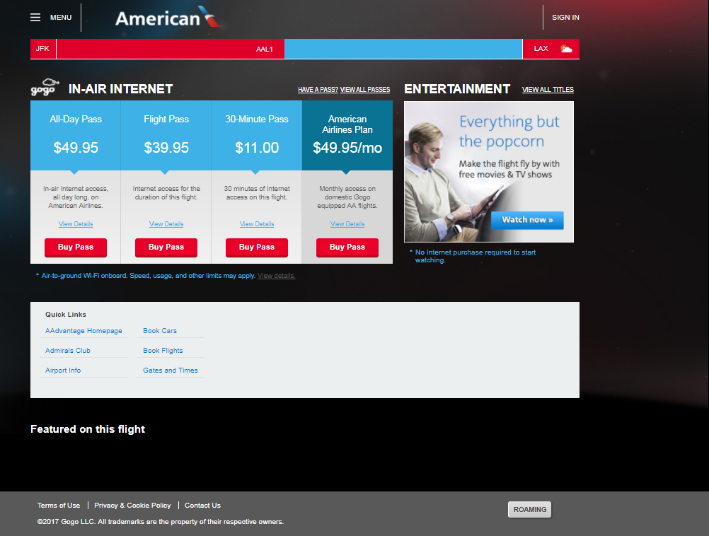

* 1. If logging in on a Delta flight, note that the ‘**Roaming’** button has moved and is now in the menu at the options at the bottom of the page:

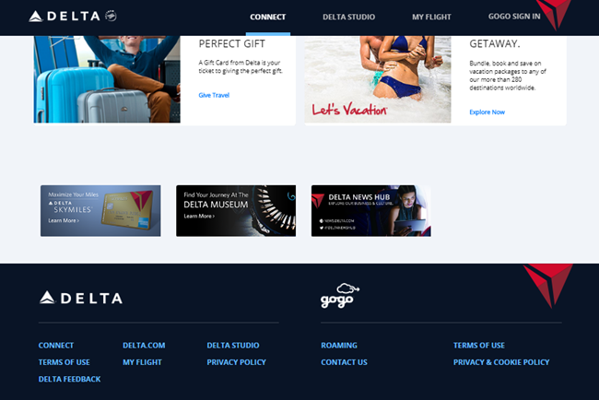

1. From the **Select your Provider** drop-down list, choose **iPass**.

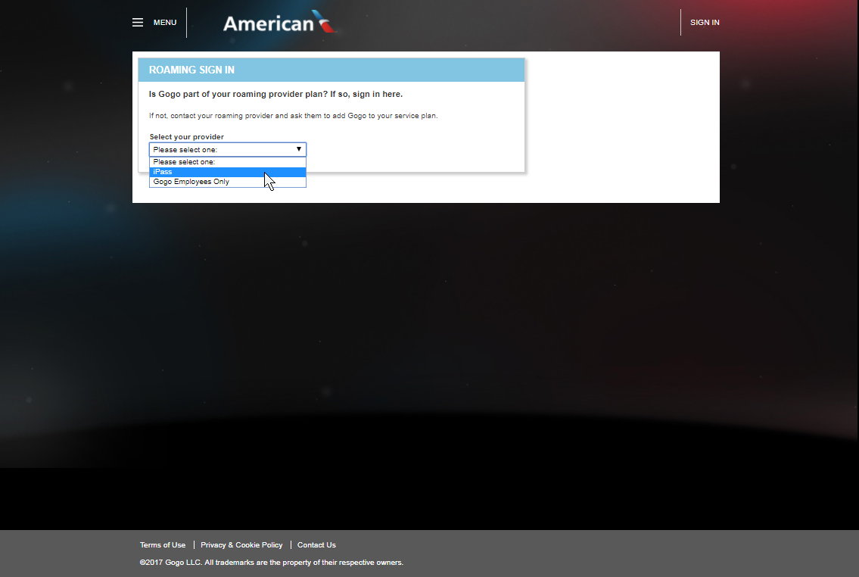

1. Enter your **iPass username + domain and password (ex. username@domain)** and tap or click **Sign In**.

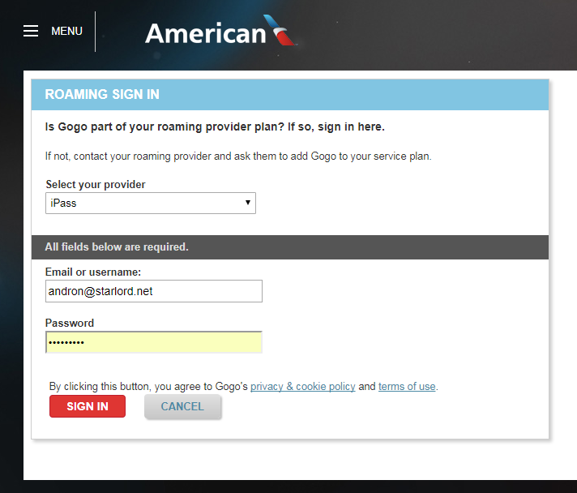

1. If on a Delta flight, **Select your Provider** and **enter your iPass username + domain and password (ex. username@domain)** on this screen:

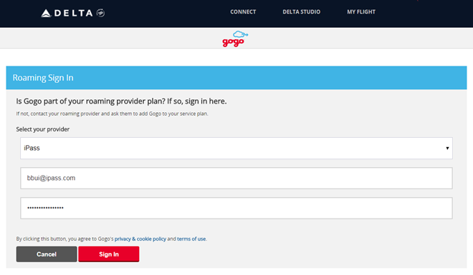

1. The CAPTCHA will promt (including Delta flights). Input the CAPTCHA characters and click submit.

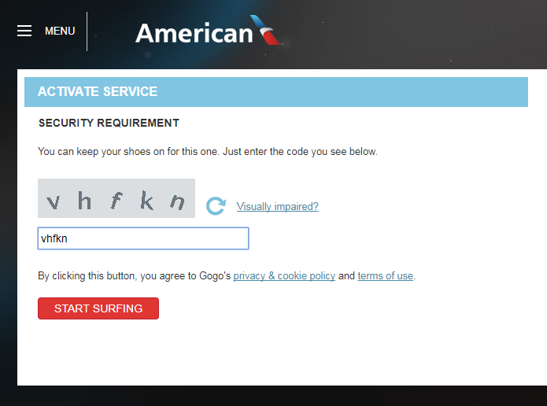

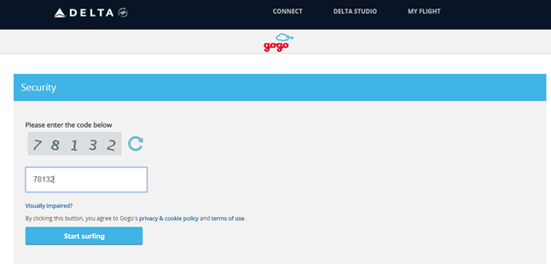

1. You should now be successfully logged in.



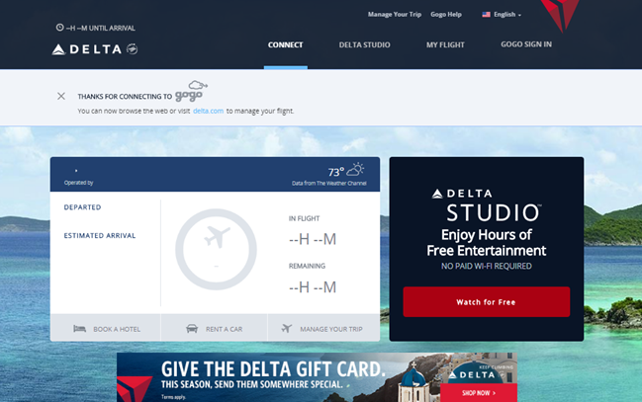

*IMPORTANT NOTE:

If you enter an incorrect username + domain and/or passwork and the correct CAPTCHA code, you will receive an ‘Activation Error’ as pictured below. Clicking ‘Try Again’ and entering another correct CAPTCHA code will still yield the ‘Activation Error’.

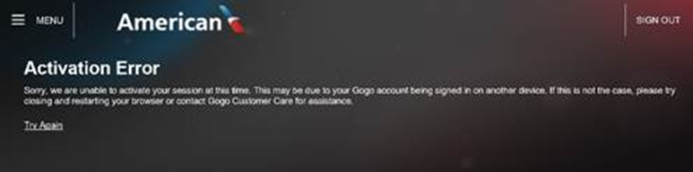

To resolve, you must click/tap the ‘SIGN OUT’ link at the top right of the page as picured below. You will then need to repeat the steps above from the beginning, being careful to enter your iPass username + domain and password correctly.

